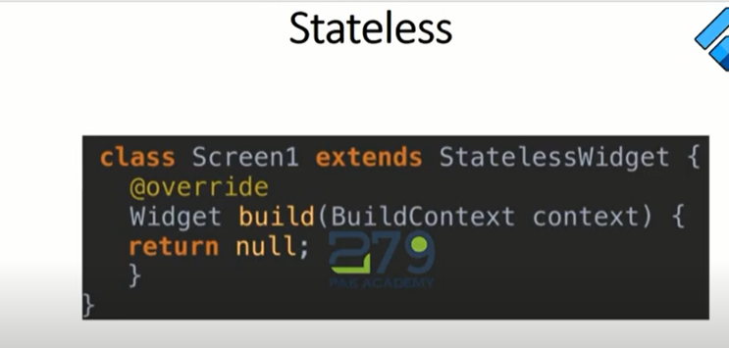

Only one method is used for stateless widget which is build metod.

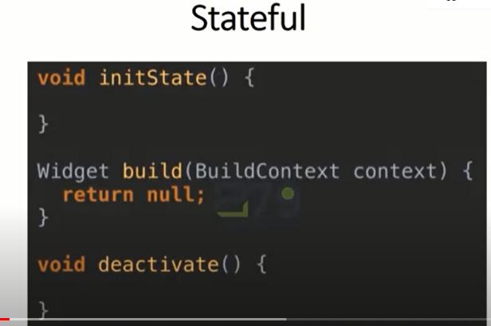

First method is initstate method.

Example:

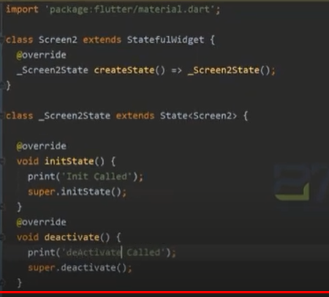

We use init method to start a widget while entering in that and deactivate method to stop a widget when leaving.

